ITCS 254: Introduction to Linux, Shell, and Commands
Lab 9 – User Environment
- Create an alias of “ls -la” command as “lla” and test it.
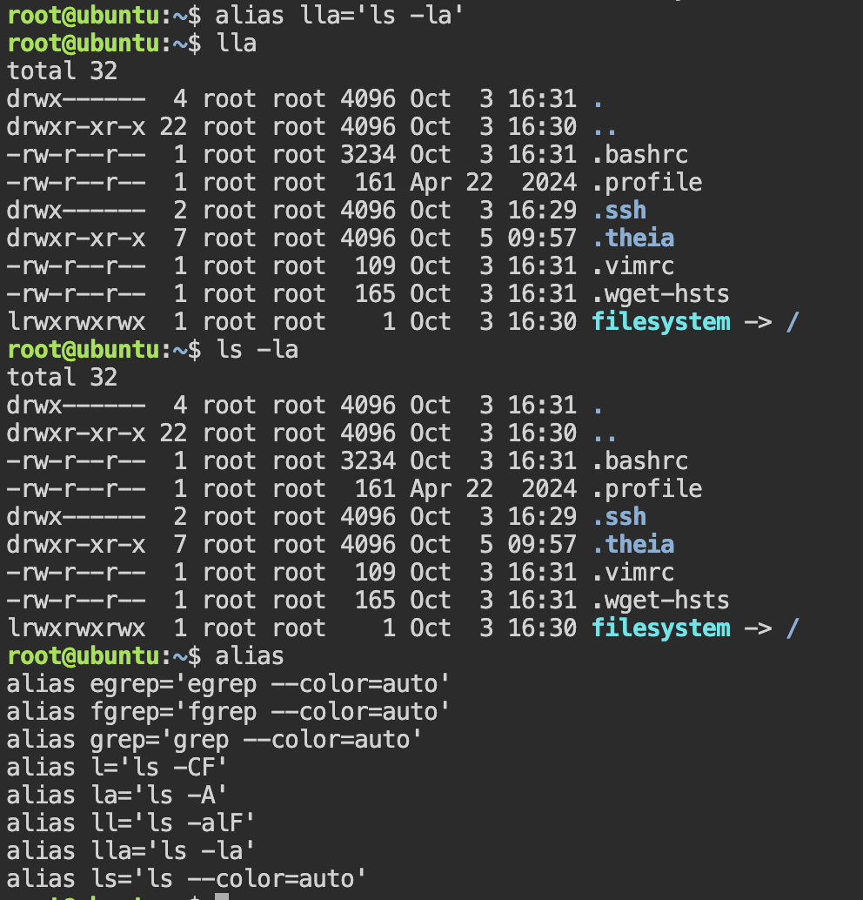

- Create a user “bob”.
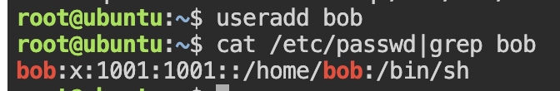
- Define the password of bob as “abc123”.
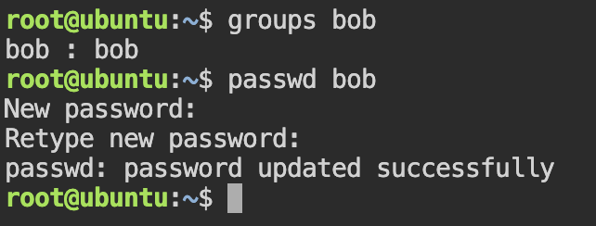
- Check /etc/passwd and /etc/group files after creating user bob.
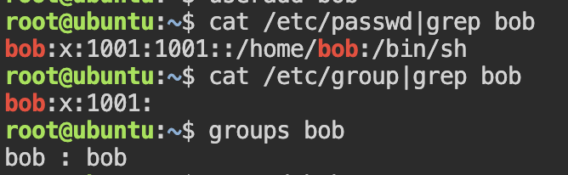
- Check which group bob belongs to
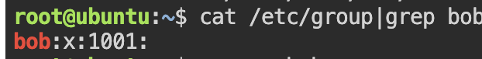
- Create two group named “dev1” and “dev2”.
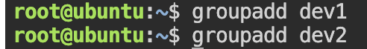
- Assign user bob to both group dev1 and dev2.
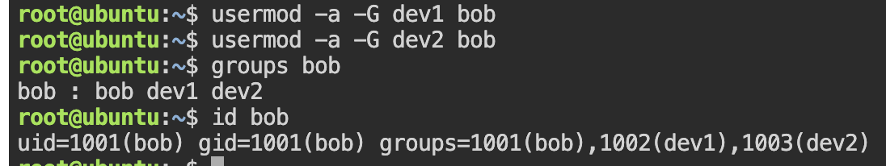

- Check again which group bob belongs to and see some changes in /etc/passwd and /etc/group files
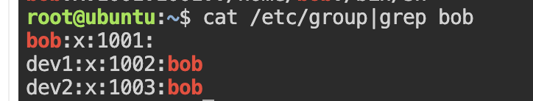
- Change bob to be in group dev1 only.
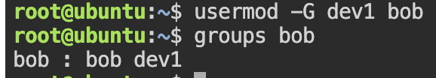
- Switch to user bob.
- Switch to root.

- Create an empty file named test.txt and check its permissions.
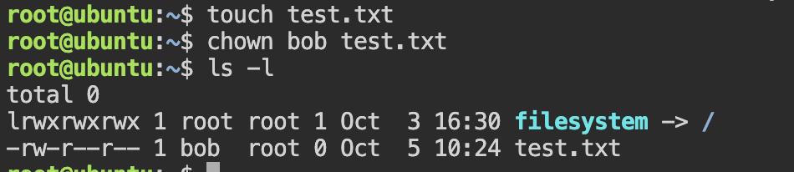
- Change bob to be the owner and dev2 to be the group owner of test.txt
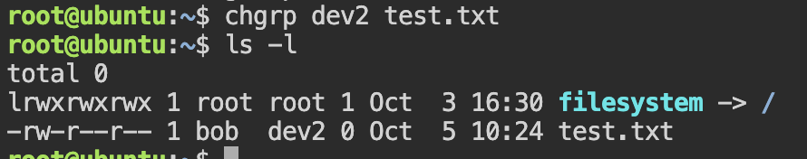
- Change permission of test.txt to be rwxrw-r-- by numeric mode and display output.
- Change permission of test.txt to be rw-rw-rw- by symbolic mode and display output.

